Topic: Bus Reservation System

Domain: Transport

Problem Statement

In today’s world of bus transportation many private bus transportation company have traditional approach of managing work on paper which seems to be money and time consuming. Also not guaranteed that all transaction to be error free and may lead to many calculation mistakes in bill generation and costing.

Online bus reservation system is a project which provides an online portal for bus ticket reservation. This application allows customers to book bus tickets from anywhere and anytime. The customer can easily book and cancel their tickets at their comfort. The customer can view all the details of the seats, bus, and route along with pictures. The customer can also view and download the details of the journey and journey timings. This will give customer an overview of the journey and will be a hassle-free task of doing bus reservation at fingertips.

The objective of application is to computerize any traveling company process to manage data, so that all the transactions become faster and there should not be any error in transactions like calculation mistake, bill generation and other things. It replaces all the paperwork. It keeps records of all the bills also, given to the customers, so that customer could update his daily accounts. All most care and back-up procedures must be established to ensure 100% successful implementation of the computerized Bus reservation system.

Mandatory Modules:

Customer Modules

* Registration: Provide registration for individual users to create account for booking tickets.
* Login: Inputs username and password to provide access to user to navigate through options for booking, cancellation and payment option.
* Bus Availability Enquiry: This module will take details from user such as departure station, destination station, travelling date span, type of ticket (one way/return), return date (for return ticket), no of passengers. This detail will be compared with the bus database and return the user details of the available buses.

* Make Reservation: Based on the selected bus, user will be required to confirm booking by going through payment module.
* Cancel Reservation: A valid user of the application will be able to cancel any booked tickets with specified time.
* Print Ticket: Printing ticket facility should be provided in the application.
* Wallet payment: Online payment options should be added in the application to provide user flexibility of choosing suitable payment options.

Admin Modules

* Update Route: Admin will have the option to update route of a bus.
* Add/Update Bus: Admin can add new bus and update existing bus details like number of seats, source, destinations etc.

Online Bus Reservation

Project Abstract:

Online Bus Reservation is a web application which provides a user-friendly User Interface and an easy efficient way to search, book and cancel bus tickets.

This application is currently working for a single bus transport company.

User have access to search buses and apply for it. User can register on website to avail privileged facilities. On booking it provides a unique ticket number through which user can track its bus details. It also allows user to cancel bus before a specific time.

Project Flow:

A visitor of the website can search for available buses by entering the source and destination stops and travel date and time span which will take them to the page where list of buses available will be displayed. On selecting a bus, user needs to click on book tickets button which will take him to payments page. Tickets can be booked with or without logging-in to the website. However, registered users will get additional facilities compared to guest users.

On unavailability of the bus/seats, an appropriate message should be displayed to the user. In the payments page, user will have set of payment modes like using wallet, net banking, debit card and credit card.

Ticket will be issued on successful transaction of payment for the tickets which later can be printed or saved in electronic form.

Validation Parameters:

During registration user will be required to enter password in a specified format like it should be more than 8 characters and in alphanumeric format and should contain one uppercase letter and one special character. This makes the password strong and difficult to crack. User is required to enter or select every field during booking process. During login the credentials are checked to make sure that the user trying to login is authorized user and will be allowed to avail the services.

Description of Modules:

1: Unauthorized reservation

On home page, customer searches availability of bus according to the desired route, based on source, destination and date. If bus is available for that route and date, then customer will check whether seats are available or not on Bus Seat-Map page. Customer can make reservation through a short process by entering his/her email and/or phone number and make payment through online payment gateway.

Upon successful reservation of bus, customer will get his E-ticket on his entered email.

2: Authorized reservation

Customer must register through sign-up page. And has to login through login page before making any reservation. Registered customer has another option of making payment through personal wallet.

Upon successful reservation of bus, customer will get his E-ticket on his entered email.

3: Coach bus reservation (authorized customers only):

Customer must register through sign-up page and has to login through login page before making any reservation. Customer will check the availability for bus and can check what all extra facilities are provided with that bus. Customer can also opt for with or without driver (if available). For without driver, customer will submit extra security deposit for security purpose.

4: Unauthorized customer cancellation

Unauthorised customers can cancel their reservation by entering their email address on which they had booked their tickets along with transaction ID (mentioned in the E-Ticket). On the cancellation page there will be two options. One for rescheduling the journey within one year and second to get the paid amount back, for which he/she must register with us to avail the amount in their personal wallet.

5: Authorized customer cancellation

Customer will be provided with an interface to cancel his journey by Clicking on sub menu Cancel Reservation of My Transaction tab. Customer will get his refund back in his/her personal wallet instantly.

6: Feedback

Customer can give feedback to us.

Admin Modules

Admin will have a separate login through which he will have the facility to add the details of buses and drivers, routes of travel and remove any bus. Admin can make analysis on following things:

Frequently travelled routes.

Last month record and profits.

Most preferred types of buses.

Customer who have registered but not made any reservation.

Reservation details of customers (daily, weekly, monthly basis)

UI Flow Description

Home Page:

The user will visit the website bus reservation system. The index page consists of navigation bar. The navigation bar includes the logo of the website. User will get options for

* Search a Bus.
* Login | Signup.

User will need to enter following details to search the availability of the bus tickets:

* Source
* Destination
* From date
* To date
* From timing
* To timing

There will be a search button after entering the above details, on clicking the search button the user will be redirected to available page.

# LOGIN/SIGNUP

User can login or signup by clicking on login/signup button.

SIGN-UP

The user will register on the website. The user needs to fill the correct details with appropriate format required in the sign-up form to sign-up on the website. The details required in the signup form are as follows:

* First name
* Last name
* Email
* Password
* Confirm password
* Contact no

There will be 2 buttons on the bottom of registration form:

* Signup button
* Cancel button

The user needs to click on the signup button after entering the above details to register on the website. If the user does not want to register, then he/she can press the cancel button. On clicking the cancel button, the user will be redirected to the homepage. If the user is already registered, then he can click on the sign-in link to login on the website.

LOGIN

After successfully registering on the website user can login on the website. If the user is not registered, then he can click on the sign-up here link to register on the website The details required for login are as follows:

* Email id
* Password

There will be 2 buttons on the bottom of registration form:

* Login
* Cancel

The user needs to fill the registered Email-id and Password to login on the website. After entering the Email id and Password user can click on remember me so that every time, he/she doesn’t need to enter his Email id and Password for logging in. On clicking the login button user will be successfully logged in to the website. If the user does not want to login then he can press the cancel button. On clicking the cancel button, the user will be redirected to the homepage. If the user forgets his/her password, then he/she can click on forgot password link. On clicking forgot password the user will be redirected to forgot password page.

# FORGOT PASSWORD

The details required for login are as follows

* Email-id

There will be 2 buttons after entering email-id

* Submit
* Cancel

The user will be prompted to enter the registered email-id. On clicking the submit button a password reset link will be sent to registered email-id. On clicking the cancel button, the user will be redirected to the homepage.

# RESET PASSWORD LINK

On clicking the reset password link the user will be redirected to resetpasswordlink page. The user will be prompted to enter the new password twice to confirm the password. System will verify whether both the passwords are same. On clicking the update button, the password of the user will be changed successfully.

# Mydashboard

The user will be redirected to MyDashboard page on clicking MyDashboard link. The dashboard page consists of header and footer. The header and footer details are the same as that of other pages. The page will include the following links in tabular form on the left hand side:

* Bookings
* Profile
* Change password
* Wallet

The user will be redirected on to a new page after clicking on any of the link.

# Bookings

The page will include the details of his current booking, past booking and cancelled booking. User can see the E-ticket. There is also an option to print ticket ,cancel ticket or reschedule the ticket. User can only print the ticket of the current booking and not of the past and cancelled booking.

# Profile

On clicking profile link, user will be redirected to his/her profile. The user can see the following in his profile:

* Name
* Dob
* Gender
* Mobile
* Email
* Address

The user can update his address ,age and gender in his profile and save the details.

# ChangePassword

On clicking the change password link , user will be redirected to ChangePassword The user has to enter the following to change his password:

* Current password
* New password

The user will be prompted to enter the new password twice to confirm password. System will verify whether both the passwords are same. On clicking the update button the password of the user will be changed successfully.

# Search

When the user enters the desired bus details and clicks on the search button he will be redirected to this page. The page will display the search results such as the availability of bus, arrival time and departure time of the bus, fare and distance. User will the confirm the bus availability and select the desired seat. The page will consist of a book button which will redirect the user to the payment page.

# BookTicket

When the user will verify the bus details, he will select the desired seat. A model consisting of bus seat layout will be displayed from which user will select the desired seat. The model will display the already booked seats and un-booked seats. The user cannot select the booked seats.

# Payment

After clicking the book button on the search page, user will be redirected to the payment page. The payment page will include various methods of payment from which user can select the method of payment. Payment module will be integrated with the bank and it will be processed in the backend.

# Home.jsp

|  |  |  |
| --- | --- | --- |
| Bus Reservation System | Login-signup |  |
| About Terms of Use Contact Us |  | |

Online Tickets Booking

To From

From To

|  |  |  |
| --- | --- | --- |
| |  | | --- | |  | |  |

Date Of Journey Date of Return(Optional)

|  |  |  |  |  |  |  |  |  |
| --- | --- | --- | --- | --- | --- | --- | --- | --- |
| Sign in |  |  |  |  |  |  |  | Sign up |

|  |  |  |
| --- | --- | --- |
| |  | | --- | |  | |  |

Search Bus

Footer

# login-signup.jsp

|  |  |
| --- | --- |
|  | |
| Sign up Forgot Password? |  |
| |  |  |  |  | | --- | --- | --- | --- | | Email id | | | | | password | | | | | |  | | --- | | Sign up | | | | |  | | --- | | Cancel | | |

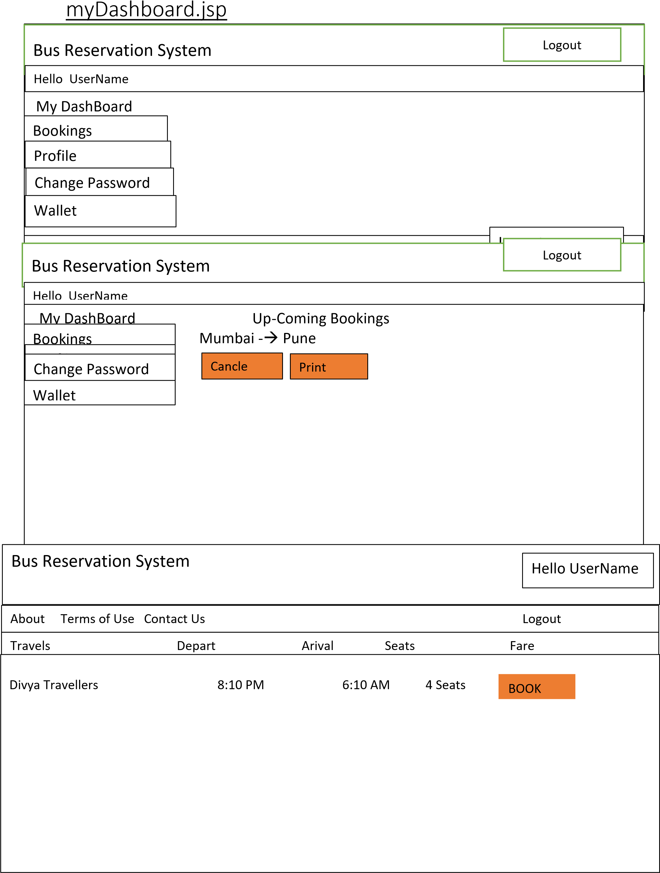

# Bookticket.jsp

|  |  |  |  |  |  |  |  |  |  |  |  |  |  |  |  |  |  |  |  |  |  |  |  |  |  |  |  |  |  |  |  |  |  |  |  |  |  |  |  |  |  |  |  |  |  |  |  |  |  |  |  |  |  |  |  |  |  |  |  |  |  |  |  |  |  |  |  |  |  |  |  |  |  |  |  |  |  |  |  |  |  |  |  |  |  |  |  |  |  |  |  |  |  |  |  |  |  |  |  |  |  |  |  |  |  |  |  |  |  |  |  |  |  |  |  |  |  |  |  |  |  |  |  |  |  |  |  |  |  |  |  |  |  |  |  |  |  |  |  |  |  |  |  |
| --- | --- | --- | --- | --- | --- | --- | --- | --- | --- | --- | --- | --- | --- | --- | --- | --- | --- | --- | --- | --- | --- | --- | --- | --- | --- | --- | --- | --- | --- | --- | --- | --- | --- | --- | --- | --- | --- | --- | --- | --- | --- | --- | --- | --- | --- | --- | --- | --- | --- | --- | --- | --- | --- | --- | --- | --- | --- | --- | --- | --- | --- | --- | --- | --- | --- | --- | --- | --- | --- | --- | --- | --- | --- | --- | --- | --- | --- | --- | --- | --- | --- | --- | --- | --- | --- | --- | --- | --- | --- | --- | --- | --- | --- | --- | --- | --- | --- | --- | --- | --- | --- | --- | --- | --- | --- | --- | --- | --- | --- | --- | --- | --- | --- | --- | --- | --- | --- | --- | --- | --- | --- | --- | --- | --- | --- | --- | --- | --- | --- | --- | --- | --- | --- | --- | --- | --- | --- | --- | --- | --- | --- | --- | --- |
| |  |  |  |  |  |  |  |  |  |  |  |  |  |  |  |  |  |  |  |  |  |  |  |  |  |  |  |  | | --- | --- | --- | --- | --- | --- | --- | --- | --- | --- | --- | --- | --- | --- | --- | --- | --- | --- | --- | --- | --- | --- | --- | --- | --- | --- | --- | --- | | 1 | |  | | | | 2 |  | | | 3 | |  | | | | 4 | |  | | | 5 | |  | | | 6 | | | |  | | --- | | 7 | | | | | | | |  | | --- | | 8 | | | | | |  | | --- | | 9 | | | | | | | |  | | --- | | 10 | | | | | | | |  | | --- | | 11 | | | | | | |  | | --- | | 12 | | | | | |  | | --- | | 13 | | | | | | | |  |  |  | | --- | --- | --- | | 14 |  | 15 | | | | | | | | | | | |  |  |  |  |  | | --- | --- | --- | --- | --- | | 16fffr |  | 17 |  | 18 | | | | | | | | | | | | | | | 19 | |  | | | 20 |  | | | | 21 | |  | | | | 22 | |  | | | 23 | |  | | | 24 | | Book | | | | | | | | | | | | | | |

Agile Methodology:

Abstract:

Agile development is a group of software development methodology based on iterative and incremental development, in which requirements and solutions evolve through collaboration between self-organizing, cross-functional teams.

Steps to follow in Agile methodology:

* You need to identify various user stories and its modules/tasks which needs to be implemented in the project as a part of Sprint planning.
* Divide all the user stories in two Sprints. Duration of each Sprint will be 3 days.
* Any backlogs of Sprint 1 should be included in Sprint 2 along with stories of Sprint 2.
* You need to prepare Scrum boards for each sprint. You can include both sprints in one scrum board if there is enough space for the same.

Instructions for writing scrum board:

* Chart papers, sketch pens, measurement scale and sticky notes will be provided for scrum board preparation.
* You need to decorate your scrum board well and it should be clean, visible and selfexplanatory.
* Discover a unique name for your project.
* Mention Group Number, TL and group member’s name in the scrum board.

Format for Scrum Board:

|  |  |  |  |  |  |  |
| --- | --- | --- | --- | --- | --- | --- |
| Your Project Name   |  | | --- | | Logo, if any |   Team Leader: <Name>  Group Members:  1.  2.  3. | | | | | |
| User Story | TO DO | In Progress | Impediments | To Verify | Done |
|  |  |  |  |  |  |